https://www.jdoodle.com/embed/v0/604p
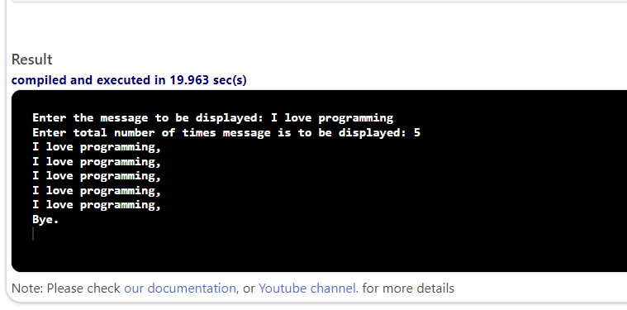

#include <iostream>
#include <string>
using namespace std;
int main()
{
string message;
int count, totalCount;
cout << "Enter the message to be displayed: ";
getline(cin, message);
cout << "Enter total number of times message is to be displayed: ";
cin >> totalCount;
for (count = 0; count < totalCount; count++)
{
cout <<"I love programming," << endl;
}
cout << "Bye." << endl;
return 0;
}

